HD 39091 (π Mensae)

π Mensae is a 1.09 M[☉](https://fr.wikipedia.org/wiki/%2525E2%252598%252589), G8 IV star1. The CH survey reported a GP (HD 39091b) with a period of 2151 days, a minimum mass of 10.08 MJup and an eccentricity of 0.64. Based on 77 RV UCLES measurements obtained between 1998 and 2015 and 282 RV HARPS measurements obtained between 2003 and 2020 coupling with astrometric measurements from the Hipparcos catalog and the second Gaia data release, a study performed in 2020 (hereafter DR20)1 found a period of 2089.11 ± 0.37 days, a true mass of 13.1 ± 1 MJup and an eccentricity of 0.645 ± 0.001. A super-earth planet (HD 39091c) with a period of 6.27 days, a true mass of 4.52 ± 0.81 Mearth and a circular orbit was found by a study performed in 20182 using 18 036 short-cadence TESS photometric measurement coupling with 42 RV UCLES measurements obtained between 1998 and 2005 and 145 RV HARPS measurements obtained between 2003 and 2018. Recently, based on 404 RV HARPS measurements obtained between 2018 and 2020 and 275 RV ESPRESSO measurements obtained between 2018 and 2019, a study performed in 20223 found a third planet (HD 39091d) with a period of days, a minimum mass of 13.38 ± 1.35 Mearth and an eccentricity of 0.220 ± 0.079.

In the present study, the DR20 RV dataset was used. Only the giant planet found in the CH survey was considered. DPASS and MCMC (1000 walkers and 300000 iterations) were used to fit the data. The properties of HD 39091b are close to those reported by the DR20.

The fits are shown in Fig 1, and the corner plot in Fig 2, and the results summarized in Table 1.

Conclusion: The properties found in the CH survey for HD 39091b are confirmed. Given the high minimum mass, the planet is at the limit of the BD domain.

Figure 1: Left: fit of the HD 39091 RV with DPASS. Red - Hir94, green - Hir04, blue - H03, cyan - H15. The blue curve shows the best fit. Right: fit of the HD 39091 RV using MCMC. The black curve shows the best fit. The colorbar corresponds to the log-likelihood of the fits. The gray dotted line indicates the end of the CH survey.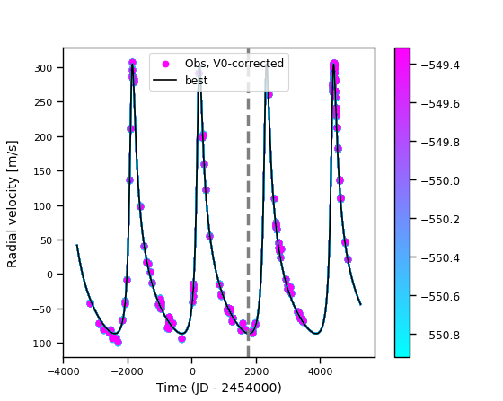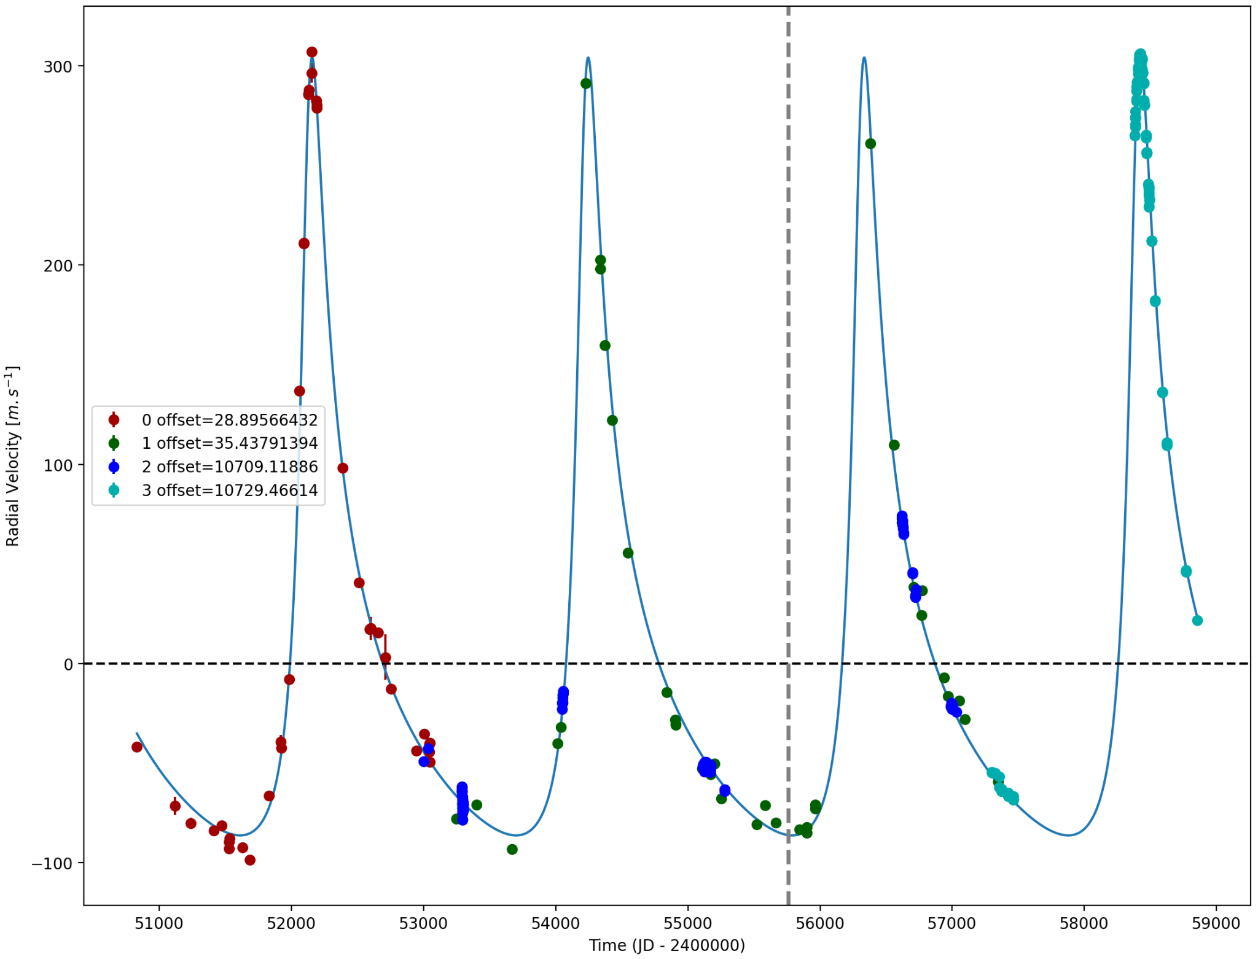

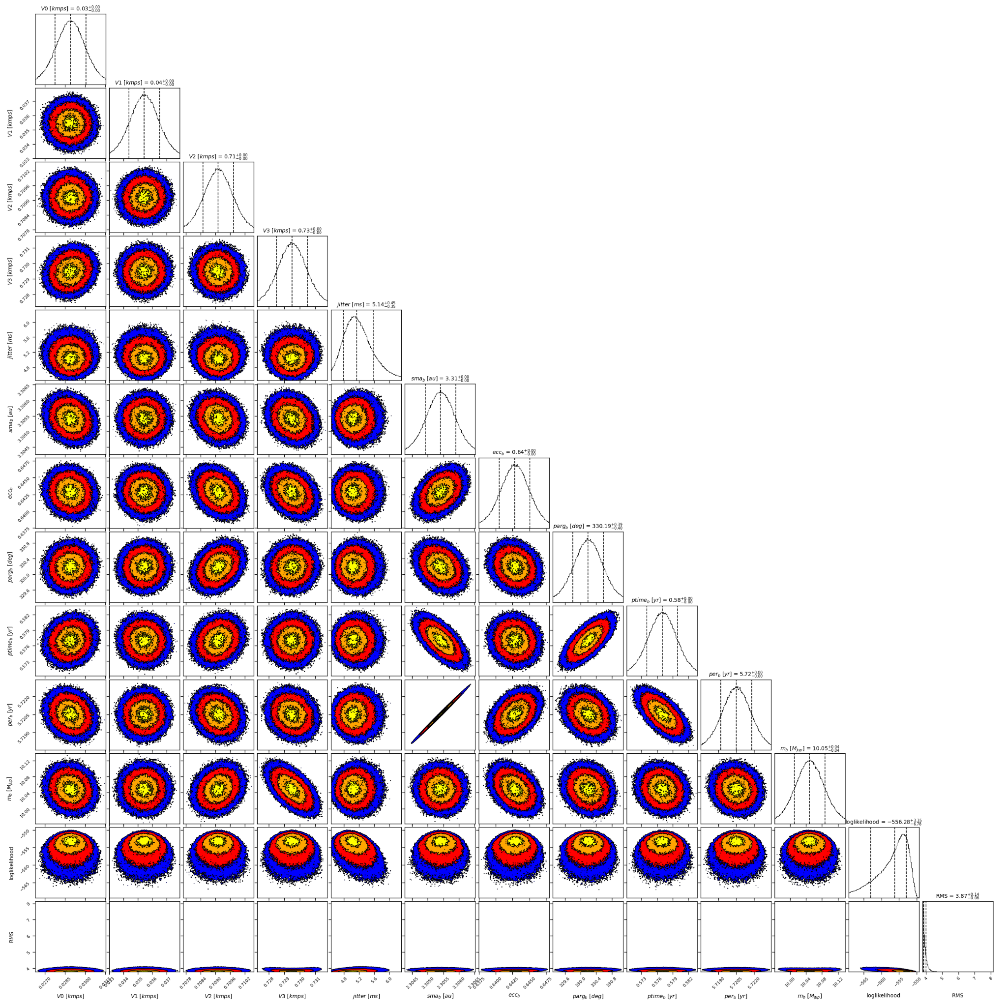

Figure 2: Corner plot of posteriors for the one-planet model MCMC fit of HD 39091 RV data.

| Parameter | Priors | | Posteriors | | CH survey |
| --- | --- | --- | --- | --- | --- |
|  | DPASS | MCMC | DPASS | MCMC |  |
| *a* (au) | [0,80] | [1,10] | 3.3 | 3.31 ± 0.01 | 3.4 |
| Msin(i) (MJup) | [0,100] | [1,20] | 10 | 10.05 ± 0.04 | 10.08 |
| Eccentricity | [0,0.95] | [0,0.95] | 0.64 | 0.64 ± 0.01 | 0.64 |
| Instrumentals offsets (km/s) | [-20,20] | Hir94: [-1,1]  Hir04: [-1,1]  H03: [9,11]  H15: [9,11] | Hir94: 0.029  Hir04: 0.035  H03: 10.709  H15: 10.730 | Hir94: 0.029 ± 0.002  Hir04:  H03:  H15: 10.730 ± 0.001 |  |
| Stellar jitter (m/s) | [0,40] | [0,20] | 4.9 |  |  |
| Argument of periastron (°) | [0,360] | [0,360] | 332 | 330 ± 1 |  |
| Phase | [0,1] | [0,1] | 0.99 | 0.10 ± 0.01 |  |

Table 1: HD 39091. Summary of priors and posteriors with DPASS and MCMC, compared to the properties reported by CH Survey.

References

1. De Rosa, R. et al. A significant mutual inclination between the planets within the π Mensae system. *Astron. Astrophys*. 640, A73 (2020).
2. Gandolfi, D. et al. TESS's first planet. A super-Earth transiting the naked-eye star π Mensae. *Astron. Astrophys*. 619, L10 (2018).
3. Hatzes, A. et al. A Radial Velocity Study of the Planetary System of π Mensae: Improved Planet Parameters for π Mensae c and a Third Planet on a 125 Day Orbit. *Astron. J.* 163, 223 (2022).